

Dr. Todd, Hurst inc.

2017-10-02

Dr. Hurst

USNV Freeman, FPO AA 02175

Phone: 7938161868

Fax: 3074517784

**Re:** Nancy, Wilson

**PHN:** 593052783

**Birthdate:** 25-Dec-1999

**Address:** 223 Kellie Inlet, Port Edwardchester, SD 13515

**Patient number:** 3728778947

To Whom It May Concern:

This is a medical letter to state the above patient is pregnant with expected delivery date of 08-Jun-2025. Hoping this information is satisfactory for your requirements.

Thank you.

Sincerely,

Dr. Todd, Hurst

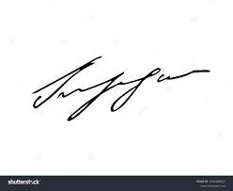

FRCS© NCMP

Clinical Assistant Professor, UBC

Department of Obstetrics and Gynecology SMH